Curriculum Intent: Modern Foreign Languages
As a school within a diverse and international local community, we value the wide range of cultures and languages which make up our school population. Our percentage of children speaking English as an additional language is much higher than the national average, and we place a strong emphasis on the importance of developing speaking and listening skills across the whole school. From the Early Years and throughout the school, we encourage children to feel proud of their own heritage and language, and to respect the language and culture of others. We encourage children to develop their conversation skills in their native language as well as in English.

In the EYFS and KS1, children become aware of the variety of languages around us, for example, celebrating other cultures, dialects, accents, and backgrounds through the wider curriculum. This allows children to foster respect for different cultures and prepare them for future language learning. Support for speakers of English as a second language is embedded in the school, both through our skilled TAs and support staff and through existing dual-language families offering support to newly arrived parents. This creates a language positive environment, which builds confidence in children new to English.

This language rich environment lays the foundation for Modern Foreign Language teaching in KS2. All KS2 classes receive weekly Spanish lessons to meet the MFL requirement of the statutory curriculum. A wide range of resources and interactive programmes are used to engage students of all abilities and provide accurate modelling of good grammar and pronunciation. Pupils are taught to express their ideas and thoughts in the target language and to understand and respond in speech and in writing. The children progressively acquire, use and apply a growing bank of vocabulary organised around topics. They are then encouraged and supported to develop their speaking and listening skills through communication and conversational work. As their confidence and skills grow, they can record their work through pictures and sentences in their MFL exercise books.

Our MFL curriculum links with our wider curriculum, particularly in Geography where we learn about languages and cultures around the world, but also in the study of other cultures within RE and History, and the celebrating of differences in PSHE. Shared learning of the grammar and vocabulary of a modern foreign language also supports our teaching of grammar and etymology in upper Key Stage 2, as well as establishing the foundation for learning further languages as the progress to High school.

United Nations Convention  on the Rights of the child | 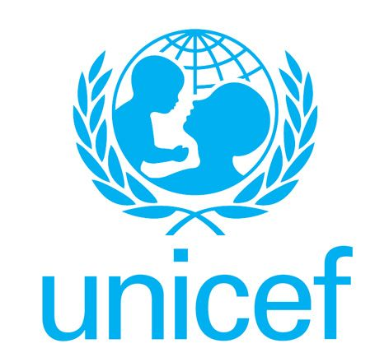
Article 29
Education must develop every child’s personality, talents and abilities to the full. It must encourage the child’s respect for human rights, as well as respect for their parents, their own and other cultures, and the environment.
Article 30
Every child has the right to learn and use the language, customs and religion of their family whether or not these are shared by the majority of the people in the country where they live.

.

